.

COST ANALYSIS

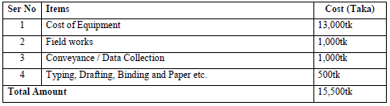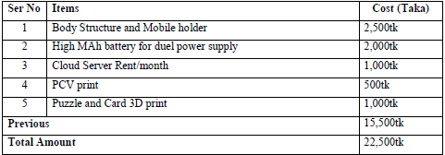

Table 2: Cost for implementing the tool industrially

Table 1: Cost for prototype

1. T. A. Castillo, C. P. de Celis, C. Lara, M. J. Somodevilla, I. H. Pineda,K. F. De Alba, and E. Romero, “Authic: Computational tool for children with autistic spectrum disorder,” in 2016 International Symposium on Computers in Education (SIIE) . IEEE, 2016, pp. 1–6.
2. S. Nur Syuhada Che Daud, M. Maria, F. Shahbodin,and I. Ahmad, “Assistive technology for autism spectrum disorder: A review of literature,” 10 2018.
3. Bartoli, C. Corradi, F. Garzotto, and M. Valoriani, “Exploring motion based touchless games for autistic children’s learning,” in Proceedings of the 12th international conference on interaction design and children ACM, 2013, pp. 102–111

REFERENCES

* To develop a game box connected with a processing system which will be able to help the parents of the autistic child to keep the record of the progress of the child in a useful way using machine learning and AI.
* To address the developmental differences in communicative function, social interaction skills, and behavioral characteristics that will be present to varying degrees for autistic children.
* To improve communicative functioning in individuals with autism, which is often delayed, both in verbal and in nonverbal communication abilities.

0BJECTIVE

# PROTOTYPE



Automated Development Tracking Tool For Children With Autism Spectrum Disorder (DevChild)

Shaila Tajmim Anuva, Md. Fourkanul Islam Mobin, Uzma Hasan, Sifat Bin Zaman & Farhana Islam Emu

Department of Computer Science and Engineering Military Institute of Science and Technology

This development tracking tool for mentally disabled children aims to act as a guide in their learning process as well as keep a track of their gradual development while playing the games in the tool. From the regular reports that generates from child’s playing criteria a therapist can get the idea of mental progress of that child. The report will also help for giving different treatment to the child. So the tool serve both the purpose of entertainment and help in treatment for the Austism suffering child and also help parents to know their child’s growth

CONCLUSION

Progress tracking of a special child is a challenging task compared to a normal child by birth. One of the widely used therapies for children with autism spectrum disorders is ABA(Applied Behaviour Analysis) training that focuses on improving a wide range of behaviours like communication, adaptive learning skills, social skills and a variety of motor skills. With the advancement of technology,a wide range of automated tools are now used in the teaching therapies of children with autism. This paper presents a sensor based gaming tool to regularly track the child’s development and find out his areas of interest. The benefit of such an automated device is to ease the task of keeping records of how well the child is developing and make learning more efficient. ABA technique has been adopted primarily in developing the games incorporated in the tool.

FEATURES

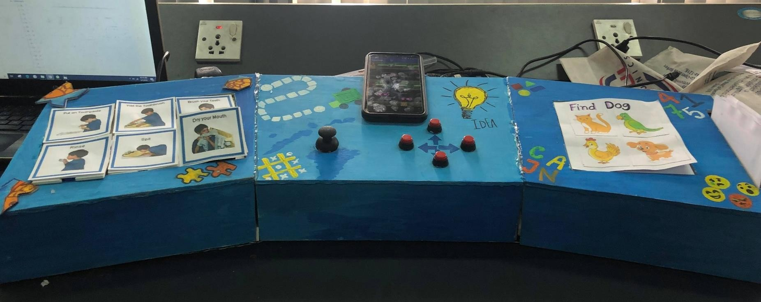

* Memory improvement games
* Puzzle solving ( matching a picture or solving a work sequence)
* improving direction skills ( reaching from start to end overcoming obstacles)
* Finding the correct object from given options( function card game)
* Storing the data in a central cloud
* Retrieval in personal account
* Daily or monthly progress in a graph
* Regular monitoring of the child
* Tracking mental growth of the child

# SYSTEM ARCHITECTURE WORK FLOW

* We planned to include modified card for game 1. This card can be modified easily by the parents or teacher of the autistic child.
* We designed game 2 as a puzzle game to teach an autistic child sequences of work and increase the ability to assemble splitted parts of any picture. In this device we placed six positions. We will Increase the positions in future. By doing so, more steps of the work sequence can be included.
* Game 3 includes a road crossing game.. In future another video game will be Included which can be played by this device. It will be basically moving from one room to another room in a house. This video game will help them to be self-dependent.

FUTURE WORK

Children with autism are the ones who go through a different development cycle than the ones who are normal by birth. Studies prove that Autism Spectrum Disorders(ASD) are complex neurodevelopmental disorders affecting as many as 1 in 88 children. Since technology these days have it’s touch in almost every sphere of our lives, thus the application of technology for the development of autistic children is a matter of consideration.

Our aim is to develop such a learning tool that will regularly track, sense and report the child’s gradual development tested while playing the games incorporated in the tool. Taking into considerations of the general methods previously followed, the developed tool will be both feasible and efficient for progress tracking of an autistic child.

INTRODUCTION